T’ai Chi: The Grand Ultimate: Lesson 3
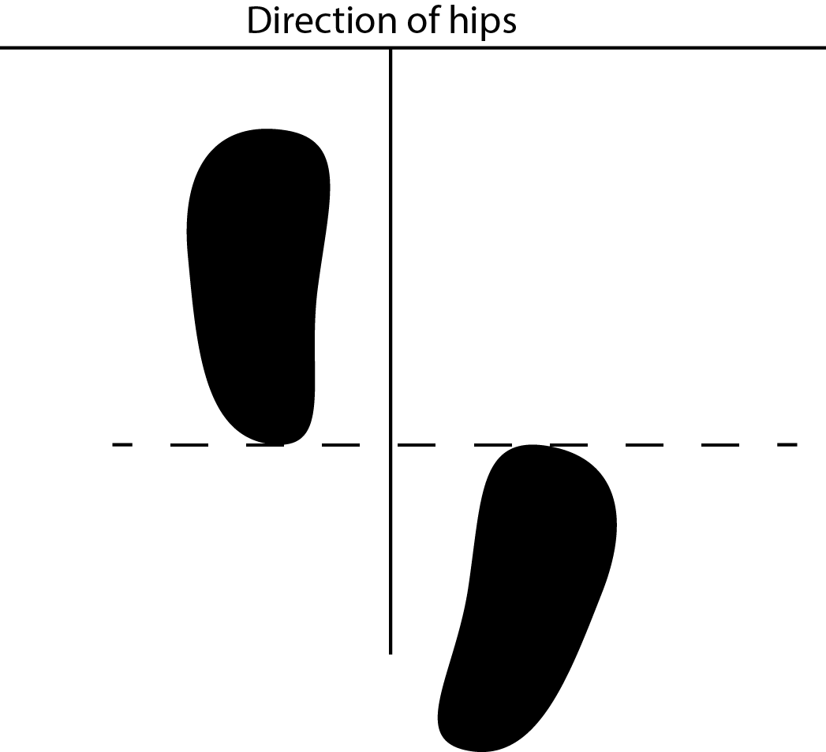
Basic Principles of T’ai Chi

T’ai chi uses the physical movements for us to understand the energetic movement
The feet are static in the movements for this lesson, but motion is quite pronounced.

Experience movement without having to move the feet. In the t’ai chi stance (diagram), practice moving the weight to the front leg, then the back leg and back again. At each point, be aware of the your balance, and your alignment. Always have the knees pointed toward the toes of the foot and sink the weight into the three nails.

Roll Away, Press, Push
From Ward Off Right
  - Turn the body slightly to the right
  - Shift the weight to the back foot (left foot)
  - Right arm comes up so you are looking at your hand, left hand is point at right elbow—much like you are holding a baby.
  - Turn the hips to the left and lower the arms, as though you are gently laying the baby down.
  - Without moving the feet, lower your center as though you were sinking into a pool of water and allow your hand to float up toward your shoulders.
  - Shifting to the front foot, the left hand presses the right palm.
  - Shift back again and separate the hands.
  - Sink a bit lower.
  - Shift forward and push—your hands should look as though they are cupping someone’s shoulders.

