T’ai Chi: The Grand Ultimate

Basic Principles of T’ai Chi

Move from a place of balance to a place of balance:
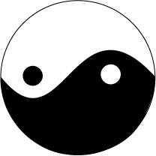
We are so busy, so stressed and so distracted so much of the time. When we take the time out of our busy schedule and simply be in the moment with our bodies, it may be surprising at how often we fall from one step into another. T’ai chi practice gives us the opportunity to learn what our balance really is and how to be in tune with it.

Move the whole body as one unit.
During our t’ai chi practice, we will learn to recognize our body as a single unit. The whole is truly greater than the sum of the parts, and we will learn together how to access the power and beauty of the movement of our bodies.

Dynamic relaxation. in order to facilitate the flow of qi or essence, learning to relax is the first step. Relaxation is referring to the muscle fibers, to being aware of where the tension is, and allowing the tension to release and the energy of the body to flow without barrier.

Energize
When we activate the muscles, utilize the breath, we deliver energy or chi throughout our body. Energizing and relaxing are key principles which we will explore throughout our practice.

The Preparation
  - Begin with heels together, toes not together
  - Sink into the right foot
  - Step out slightly with the left, the toes pointing directly forward
  - Shift the weight to the left foot, and turn the right toes forward
  - Center the weight on both feet
The Beginning
  - The wrists rise up, like you are a puppet on strings
  - Relax and let the hands come back to the shoulders
  - The hands pop up to show the palms
  - Then the hands slowly fall to your sides

